The Products Creation Guru

Table of Contents

Introduction: Why Sell Information products online?
Chapter One: Pick Your Information Product
Chapter Two: Product Creation and Branding
Chapter Three: Creating Your Info-Product
Chapter Four: Pricing and How to Get Testimonials
Chapter Five: Selling Your Product

Introduction: Why Sell Information products online?

I’m going to show you the oh so simple secrets of creating effective, profitable information products. These are the very same SIMPLE secrets used by information product gurus. Simple yes, but also deadly effective and hugely profitable...
There are so many advantages to creating information products that it’s hard to list them all, but here are a few:
Information products are extremely easy to produce.
Information products are extremely cheap to produce.
When you start most businesses you go straight into debt. You might have to buy or rent premises, buy your stock, fit out a store, install technology etc etc and before you know it you’re $50,000 in debt before you even start trading.
Selling information products online is a way to start your own business with little or sometime NO overheads.
Also Information products are very versatile.
You can sell them at a profit, give them away as an incentive to get people to sign up for your list, sell them at a low price to showcase your skills and then offer higher priced products...There’s a whole world of ways to use information products to build an online business.
So what do we mean when we say information products?
Any product that gives people information, usually a solution to some sort of problem. People pay to get out of the hole they just fell in – not how to avoid holes. Solutions to problems always sell well.
For instance a product could tell people how to train a dog, lose weight, design a website, cure bad breath, meet members of the opposite sex, put up shelves, apply makeup, or paint a portrait using oil paintings.
An information product can be made in video form, as en ebook, or as an audio recording. Some types of information products lend themselves better to one form than another. For instance if you are telling people how to apply makeup you definitely need visuals, so a video would be best. An audio recording wouldn’t do the trick in this case and an ebook would need to have a lot of screenshots.
If you want to tell someone how to meet members of the opposite sex, however, an ebook or an audio recording would work well.
And if you want to tell someone how to train a dog, an ebook with screen shots, or a video, would work equally well.
Find your subject, then decide on the best way to present it – ebook, audio, video etc.

Chapter One: Pick Your Information Product

One of the biggest hurdles new internet marketers face is choosing what type of information product to create.
Since you most likely want to make a profit off of this, you need to create an information product that solves a problem or tells people how to do something.
Solving problems is profitable.
Also, you want to make sure that there’s a decent sized audience for this product, and you want to make sure that they have money to spend.
So you wouldn’t want to create an information product that solves a really obscure problem that is only faced by a tiny group of people. And you wouldn’t want to create an information product that appeals to a crowd that has no money to spend, such as young teenagers or children.
Here is a list of evergreen product ideas where you will always find a hungry crowd. Provide these people with a genuinely helpful solution to their problem and you will have a grateful crowd that will come back again and again:
Weight Loss
Dog training
Pet health
Acne cures
Curing romantic woes
Saving money
Debt Consolidation
Avoiding foreclosure
Fitness
Parenting
Fertility
Making money online
Driving targeted traffic to websites

This doesn’t mean that you should only stick to that list, by any means. If you have a skill and you can teach other people - for instance, as we mentioned earlier, applying makeup or painting a portrait or arts and crafts or home repairs - by all means create an information product around it.
You need to make your information product stand out, so you would want to develop a method that lets people learn how to do something quickly and easily, and emphasize that when promoting your product.
“Learn How to Paint Portraits Quickly And Easily!”
“Take Pictures Like A Pro - Learn How in Just Five Lessons!”
You get the idea.
If you’re searching for ideas, try to identify what potential customers need. You can do this by doing some basic Google searches and by visiting internet forums or blogs that are targeted to the area that you want to create a product for - dog training, weight loss, dating forums, etc.
Here’s one way to find out what people need - go to Google and type in the phrase “How To” in quotes.
Here are some of the things that you will find on the first page:
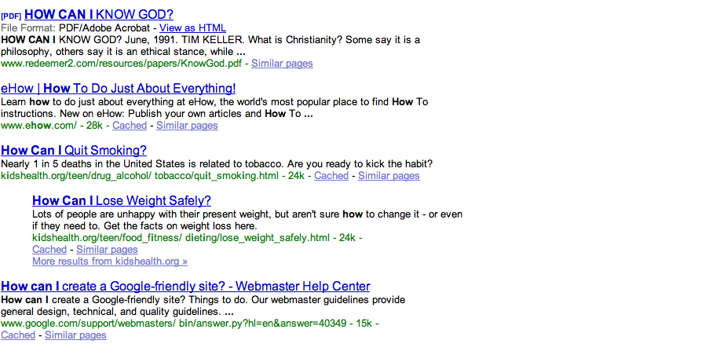

Some product ideas there would be a weight loss product, or a quit smoking through hypnosis product, or, if you are religious, a product that helps people reconnect with their spirituality.
Or, a manual that gives people tips on creating a Google friendly site, if you know anything about SEO.
Don’t ever be put off by the fact that the product may already exist.
In fact, if there are NO other versions of the product - you should worry. That possibly means there is no market.
There is nothing new under the sun - but people who have an interest in an area tend to buy a LOT of products that address that interest.
If someone is a fanatic about dog training, they are likely going to buy more than one book on it. If someone is desperate for romance, they will snap up any product that looks like they offer a solution.
You need to create an excellent product that solves the problem, emphasize how good your product is when you are promoting it, highlight some common flaws that competing products have and how your product is better than the other products...and it won’t matter how many other competing products are out there. Really.
Another way to find out what people need is to go to Yahoo! Answers and see what people are asking for help with.
When you go to www.answers.yahoo.com, you will see a list of categories on the left hand side of the page. If you have an idea of what general type of information product that you want to create, you can click on the category that you are interested in and see what types of questions people are asking.
Below is the list of categories:

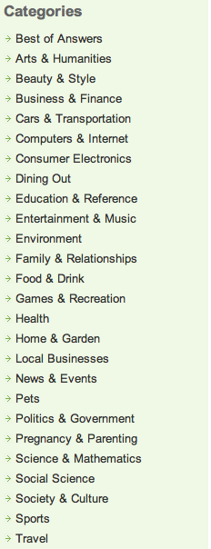

So, if you wanted to create a pet product, you would click on pets and you would see what kinds of questions people are asking about their pets.
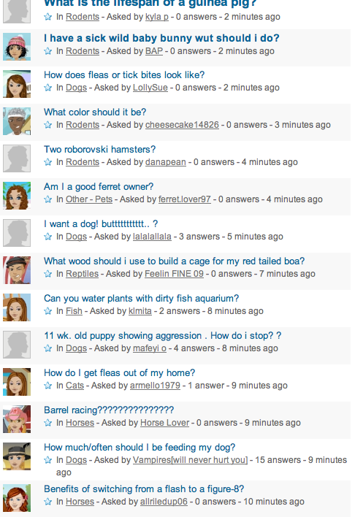

If you wanted to narrow it down to horses or dogs or cats or some other type of animal, there is a list on the left of the page of different categories of pets, which you can also click on:

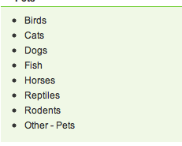

Just by seeing the common questions that crop up, you will be able to identify a need for information - and fill that need by creating an information product.

You can also find forums by going to a search engine such as Google or Yahoo or Altavista and typing in, for example, “dog forum” or “chihuahua forum” or “DIY decorating forum” or “web design forum” or whatever your chosen topic is.
It’s important to make sure that there is actually a market out there that is seeking a product like yours.

And once you have done that, you can go on to the next step...product creation.

Chapter Two: Product Creation and Branding

Once you have a general idea of what subject you want to write about in your information products, you should start thinking about branding yourself and your product line.
Creating a brand identity is a way to build customer loyalty and to ensure that when customers are looking for a solution, they think of you first.
Think of someone like Cesar Milano, and you automatically think “The Dog Whisperer”.
When you think of home decorating, what name pops into your head? Chances are pretty good that it’s Martha Stewart.
Think of cooking, and you’ve got a lot of different options...Emeril Lagasse...Rachael Ray...and yet even there, people have found ways to distinguish themselves. Extreme eating, adventures in dining - Anthony Bourdain! Southern cooking - Paula Deen!
If you’re from the UK you might think of Jamie Oliver when you think about School Dinners or Barbara Woodhouse when you think of dog
training. If you think about money saving in the UK you think about Martin Lewis. When you arrive at his website the first thing you see is a picture of him. That tells you immediately you’ve come to the right place. Branding!
This branding allows them to build and build on their success.
Once you are known for producing an excellent product, people will come back to see what else you’ve got available, and when you create a list of satisfied customers and notify them that you’ve got something new, if you have established a brand for yourself, they are much more likely to want to purchase it.
You can, of course, choose to design a single product or a series of unrelated products, but you’re missing a great opportunity to build up buzz and repeatedly sell to the same customers when you do that.
To create a brand identity it helps to have a consistent visual theme for your web endeavors - a similar design and color scheme for your website, your ebooks, your short reports, etc.
If you don’t have any design skills, no problem. You can go somewhere like elance.com, guru.com, rentacoder.com, or any other freelance website, and find a graphics designer to create a logo and website header for you that will represent your business.
You don’t have to get any fancier than that. People aren’t looking for fancy website design when they land at your website. They want to know that they’ve arrived at the right place - and will be instantly reassured when they see your familiar looking banner.

Then, they want the information that they came here to find - how to save money with coupons while shopping at grocery stores, how to litter train their cat, how to flatten their abs, etc.
And they want the site to be easy to navigate - they don’t want to have to hunt around to find what they are looking for.
So all you need to help establish your brand identity is a custom designed banner and logo that visually tells the customer at a glance what you and your products are all about. You can adapt that logo and banner and use some version of it for all of your products.
Let’s take the coupon example, for instance.
You decide that you want to be the coupon queen. An obvious thing to do would be to get a crown logo designed; perhaps a crown sitting on top of a pile of coupons. From then one when anyone sees that logo and the phrase “The Coupon Queen” they know it’s one of your products.
You would want to include your brand name in your product title if possible. “The Coupon Queen’s tips for getting groceries FOR FREE!” or “The Coupon Queen’s 50 delicious low cost recipes!”
Or, to use a more masculine example, say you are an expert fisherman and hunter and you want to create a series of information products that will teach people to fish and hunt.
You could create a brand identity like “The Good Ole Boy’s guide to Bass Fishing.” This could spin off a whole series of ebooks, instructional videos, product endorsements and so on.
The possibilities are only limited by your imagination.
Some of it sounds clichéd, and perhaps even tacky. But it works beyond your wildest dreams!

Chapter Three: Creating Your Info-Product

Now, we’re going to talk about what form your information product is going to take.
There is a lot of talk these days about how video information products are hot and everyone prefers video.
Don’t believe it.
Video is perfect for some types of information products and not so hot for others. And not everyone loves video.
There can be drawbacks to presenting information in video form. People have limited time and short attention spans these days, and it’s a lot easier to scan an ebook and get what information you need than it is to scan a video. Then again some people claim the exact opposite.
It’s very hard however to fast forward an online video that is still loading to see if it contains the relevant information than it is to look at the contents page of an ebook.
So your video must be well made and get to the point immediately, with no fluff or lengthy introductions, or you will anger people and get a lot of refund requests, and people will not be likely to order from you again.
In a written product, people are a little more forgiving, because they can page forward quickly to get to the information that they need.
If you are talking about how to design a web site, for instance, they may already know some of what you are discussing. In an ebook they can skip what they already know; in a video they can’t, because they don’t know where on the video to find the part of the video that they are looking for.
However, some information products do naturally lend themselves to ebook form or audio form.

If you can interview an expert, like an internet marketing guru, an audio form works quite well. If you have an information product that does not rely on visuals (like teaching someone how to paint a portrait), the audio form works quite well.
An audio recording is also a good option for people who are visually impaired.
Video can definitely jazz up an information product. Say you have a cookbook; anyone can write a cookbook, but if you show each step of the cookbook process, along with a picture of the cookbook at the end, you present a much more tantalizing picture.
If you want to show how to train a dog, it’s easy to say a technique, but to show a video of an unruly dog, and then you using the training techniques, and then that same dog behaving perfectly and obeying commands...is very powerful.
So how do you actually go about creating your information products?
It can be done very cheaply and easily.
Your computer may already come with a word processing program which can save a document in Portable Document Format. (pdf) If not, there are numerous paid options available, or you can download Open Office, which is free and works with both Macintosh and PC platforms. CutePDF works with several Windows platforms including Vista.
To make a video, there are a number of free and low cost programs available.
Macintosh users can use imovie software, which also comes with Garageband software that is great for podcasts and audio recordings. It costs about $79.
Videospin is a free video editing program that works with Windows XP. Camstudio is a free video editing program that works with
Many Windows computers come with the program Windows Movie Maker, which may be all that you need.
Jingproject.com also has screen capture software and video editing software and works with Macs and Windows. It is free; can’t beat that price!
Camtasia is a wonderful screen capture and video editing program that is very popular with internet marketers and works with Macs and Windows. It is pricey, however, currently at $299. It comes with a 30-day free trial.
Realistically speaking, the programs that cost money are going to have more features available then the free programs, but for the purposes of creating an information products, the free products are more than sufficient.
When you create a written information product, like an ebook or short report, you are going to want to save it both in regular format and also in PDF, so that you can export it.
When you create a video or audio product, you may want to lead in with a short audio jingle - 5 seconds or so - or you may just want to start right in with the information product.
Video editing programs will allow you to add in titles and transition effects to your video, such as fading from one screenshot to another. Keep in mind that when you add in transition effects it can take longer for the product to download.
Don’t be nervous about making a perfect video; purchasers of information products don’t expect a Hollywood production. They have a problem; they want someone to tell them how to solve it, quickly and with no distractions. They’re not looking for fancy special effects.
One thing that is important in making your product look good is getting an attractive digital cover made.
They generally cost between $25-$97 - you definitely shouldn’t have to pay more than that - and you can find good ecover designers on The Warrior Forum, elance.com, rentacoder, guru.com and other freelance sites.
You will need to tell the designer the theme of your information product, what your author name is (you can use your real name, use a pseudonym, or use no name at all) and what the product title is.
You can also tell him what color scheme you want.
If you are creating an ebook he’ll create an ebook cover. If you’re creating a video he’ll create a CD cover. These are just photographs that you will have on the site that sells your product; you’re probably not going to mail out actual CDs because your costs would go through the roof.

Chapter Four: Pricing and How to Get Testimonials

Pricing is always a delicate issue, because if you charge too much people won’t buy, but if you charge too little, people might perceive that what you are selling has no value.
You should start out by looking at other information products that are similar to yours and examine their sales pages thoroughly to get an idea of what they offer and how much they charge for their product.
You don’t want to charge too much more than the other people in your field.
However you want to see what they have to offer versus what you have to offer.
If they are just selling a 20 page ebook on puppy training and you are selling a 100 page ebook on dog training from puppyhood through adulthood, along with a set of step by step videos...then of course you should charge significantly more.
The puppy ebook might sell for anywhere up to $17. The dog training ebook plus videos might sell for up to $67.
Or, you could offer the ebook at a cheaper price, say $37, and then offer the videos as an “upsell”. They might cost and additional $30 or so.
You may have noticed that the prices quote here end in seven. There have been numerous internet marketing studies on this and oddly, prices ending in seven outsell other prices ending in the traditional .95 - $9.95, for instance.
That holds true even if the number ending in 5 is several dollars cheaper.
A product that sells for $19.97 has been shown (in some instances) to outsell a product that sells for $15.95.
Another thing to consider is whether you want to give the product away to start building a list.
This method can work very well if you have back end products that you want to sell.
In the dog-training example, you could offer a free five-day course to teach people how to housebreak a dog, or how to handle a dog’s excessive barking.
Each day you would mail out the day’s lesson using an autoresponder service like Aweber, Getresponse, or Constant Contact.
In each email you would have a link at the top and at the bottom of the email, offering people a chance to click on the link and order your product. Then, you give a helpful, well-written lesson about your subject, again without giving away everything - just enough to show that you know your stuff.
If it’s a video or audio that you are selling, you could give away the first video or audio recording in the series to show the quality that the customer will be getting - in exchange for their name and email so you can use it to build a list.
Now, you need to start planning out the sales page for your product.
Again, one of the best things that you can do is study the sales pages of your competition.
You don’t want to copy them, of course; you want to see what they offer and make sure that you present a more compelling offer.
For instance if someone is selling an ebook about dog training you want to emphasize that your ebook comes with videos to actually demonstrate what you are talking about.
If someone is selling a video series about painting a landscape, you want to make one that is more thorough or that offers some type of free bonus like a video on how to paint a portrait.
You also want to get an idea of how sales pages are structured.
Starting at the top, you will see that sales pages often have large, attention grabbing headlines. Many websites use this type of headline because – simply – it works.
The headline needs to be about the benefits that your product delivers. It needs to tell the customer what relief they can expect from buying your product.
It could say something like “Cure Your Dog’s Bad Habits Faster Than You Thought Possible!” or “Trim That Extra Tummy Flab In Weeks!”
or “Supercharge Your Metabolism With These Superfoods!”
Notice that sales pages do not have long unbroken blocks of text. Under the headline you want a photograph, a paragraph or two about your product, and then a “sub-head”. You need to make it easy to read. The clip art in this book serves the same purpose – it breaks up chunks of text and makes it easier on the eye and easier to read.
You want a series of paragraphs and subheads.
At some point a list of bullet points is also helpful. They should summarize your products benefits or highlight how it’s better than its competitors.
Example:
This product DOES NOT rely on:
- Expensive exercise equipment that’s impossible to put together!
- Fad diets that make you sick!
- Gross food supplements that taste horrible!
- Hours of torturous exercise!

This is good because it mentions negative points about your competitors and what they offer - subtly, of course, without naming names - and thus by contrast highlights the good things that you have to offer.
Customers have most likely tried many of those things before and have obviously failed or they wouldn’t still be dieting, so they will be eager to find a product that offers them something different.
You also want a clear “call to action” which tells the customer what to do, and you want it to be prominently displayed in several places on your sales page.
This is very important. If the customer can not easily figure out what to do next when they come to your sales page, they will hit the back button and you will likely lose them forever.
The call to action would say something like “To lose that excess tummy flab NOW, click here to place your secure order via paypal.”
You can also throw in a time element to make it more urgent, or a scarcity element.
If you are using a time element you would say something like “For the first 48 hours, we are going to offer a free downloadable cookbook of low calorie recipes to each person who orders...” et cetera.
You must cut this off after 48 hours and remove that statement from the sales page when the bonus offer expires, because if you don’t, people will not take you seriously any more.
Remember, you are building brand loyalty here. You can’t do that if you show people that you make statements that aren’t true.
For scarcity, it helps if you have a physical object that you will mail to everyone who orders from you. It’s hard to claim that you have a limited number of ebooks to give away as bonuses because everyone knows that’s not true. You can give away an infinite number of ebooks.
You could also offer something like a free one-hour consultation with you, if the information product is appropriate to that type of offer. You could offer it to the first 10 or 20 people who order.
And finally, on your sales page, you need to offer customer testimonials.
‘Wait’!, you say.
How do I get testimonials?
I haven’t even started selling the product yet!
Here’s what you do: you give away copies of the product to a few people in exchange for their honest review.
Most people are going to say something nice about your product. If you get a lot of criticism, then honestly, you should rethink your product and probably make some changes, especially if they all mention the same thing, such as “It wasn’t explained clearly enough.”
If you don’t know anyone personally who you feel will provide a good testimonial, you can go on an internet marketing forum and explain that you are creating a new product and would like to provide free copies to the first ten people who contact you, in exchange for their honest testimonial on it.
(You can’t ask that they only say good things about it, but if you have created a quality product, rest assured that most if not all of the comments will be positive.)
Digitalpoint Forums and The Warrior Forum and Webmaster World have very active internet marketing communities. It’s worth joining just to learn about how to promote products online.
In fact before you ask for a testimonial it’s worth posting a few times, introducing yourself, and contributing to the conversation so that people can get to know you a little bit before you request a favor out of the blue.
Do this for a couple of weeks and you will learn a lot, make good connections, and when you do ask for those testimonials you will be much more likely to get a bunch of people responding favorably.

Chapter Five: Selling Your Product

This is equally as important as creating your product. You can create the best, most useful product in the world but that doesn’t do you much good if you don’t know how to sell it, does it? Your product doesn’t make you any money sitting on your hard drive.
There are numerous ways to sell an information product online and you may end up choosing to use several of them.
One way to do it is using Google Adwords pay per click. This is being mentioned only briefly here because learning how to do well with Google Adwords would fill another ebook entirely.
Adwords are the advertising links that you see in blue on the right side of Google Search pages. MSN and Yahoo have their own versions as well.
If you had a dog training ebook you would bid to have your adwords ad appear when people typed in relevant search phrases like “Dog Training” or “How To Teach My Dog To Sit”.
You have to constantly monitor your ad campaigns to see which ones are profitable and shut down the ones that are not showing enough return on investment.
You also have to make sure you set a daily spending limit, or your adwords bill could be in the thousands of dollars or pounds for an unprofitable ad campaign.
Some people make their living entirely by selling information products through adwords, so that is certainly an option. If you want to learn about adwords, read through all of Google’s own tutorials on the subject, and then buy some books on Adwords as well.
Another place to sell an information product is on The Warrior Forum, a popular internet marketing forum.
Again, you need to join the forum, and then join the conversation there and post regularly for at least a few weeks.
Then, you can go to the section of the site titled “Warrior Special Offers” and start out selling your information product there, if it is appropriate.
This works better if your product is related to internet marketing. Also, you need to offer the product at a price better than is offered to the general public, which is why it’s called a “special offers” section.
You could offer the first fifty copies of the book on sale, or
There are a number of rules regarding Warrior Special Offers; make sure to read them carefully. It currently costs $20 to post a Warrior Special Offer.
Another very popular way to sell your product is through Clickbank.
Clickbank only (at time of writing) specializes in downloadable products. You have to apply to be a merchant on Clickbank and there is a one time set up fee.
Then, you can encourage affiliates to sell your product for you, in exchange for a generous commission.
To entice affiliates you are going to have to offer a really large percentage of the product price, at least 50 percent and preferably 70 percent.
However, look at it this way. The affiliates will do all of the hard work for you, paying for adwords to drive traffic to your sales page, writing articles for article marketing directories that link to their pre sell page or to your sales page, creating pre-sell pages that link to your sales page...and the more you pay them, the more incentive they have to work hard to sell your product.
Here are some tips to keep your affiliates happy and to attract good affiliates:
Never undersell your affiliates. Do not offer your product for $25 if you have set the price they will promote it at $37.
Offer good affiliate support. Offer them artwork to put on their sales page, showing your product; several different product pictures would be ideal. A picture of the ebook cover and a banner ad at the bare minimum, would be helpful.
Offer them several custom written articles that they can then rewrite and submit to article directories.
Offer them a free squeeze page that they can put their affiliate link on.
Offer a cash bonus for every 100 copies of your product sold.
Make sure that the terms and conditions of your affiliate offer are clear and specify what the affiliates can and can’t do: no misleading ads, etc.
So you know know how to create an information product, how to price it, and where to sell it. The only thing left for you to do is get cracking and start building your profitable information product empire!

Summary
Creating information products to sell online is, I think, one of the most exciting and accessible businesses EVER.
You don’t have to have any qualifications, experience or expertise to start selling info products and the start up costs can be little more than zero.
This is important because it means you can try out different ways of selling and different types of info products without risking much cash.
It also means that if you have just a few sales and maybe pocket $200, you’re still in profit, and it was worth doing.
If you’ve got a PC and internet connection and an interest in making money online then there’s really no excuse for Not trying to profit from info products. It’s a fabulous business and never before in the entire history of man, has the technological and sociological era been as ripe as it is now, for smart people to profit from info products with little or no start up costs.
Go grab your share!

